Sheet 2 Assignment 4
Team 11

Modified Files:

File: lib/test/analysis/plot_results.py

At the end of each of these functions:

print_results
print_per_sequence_results

Added this code:

with open('/kaggle/working/SeqTrack/Inference_rate_results.txt', 'w') as f:
f.write(report_text)

To save the printed output in a text file.

………………………………………………………………………………………………………………..

File: tracking/analysis_results.py

Added these lines to call the functions to save the needed plots:

print_per_sequence_results(trackers, dataset, dataset_name, merge_results=False, filter_criteria=None)

plot_results(trackers, dataset, dataset_name, merge_results=True,
plot_types=('success', 'prec', 'norm_prec'))

Running:

Run this command to start testing, then second one to analyze results.

python tracking/test.py seqtrack seqtrack_b256 --dataset lasot --threads 4
python tracking/analysis_results.py

Results (Epoch 3):

Table 1: Inference rate results

Sequence | FPS
mouse-17 (ID=0) | 0.13
mouse-18 (ID=1) | 0.11
mouse-19 (ID=2) | 0.06
mouse-20 (ID=3) | 0.16
electricfan-17 (ID=4) | 0.41
electricfan-18 (ID=5) | 0.17
electricfan-19 (ID=6) | 0.19
electricfan-20 (ID=7) | 0.11

Table 2: Inference rate results

AUC | OP50 | OP75 | Precision | NormPrec
0.63 | 0.05 | 0.05 | 1.13 | 2.45

Graphs (Epoch 3):

The provided plots (Success, Precision) visualize final evaluation results after training, showing IoU- and distance-based performance across varying thresholds.

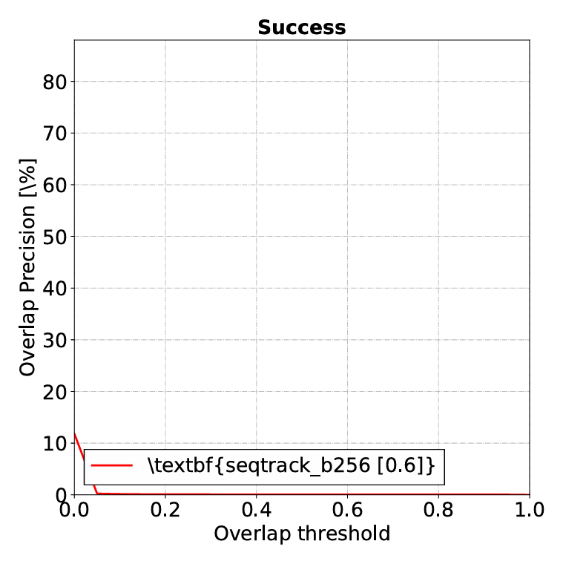

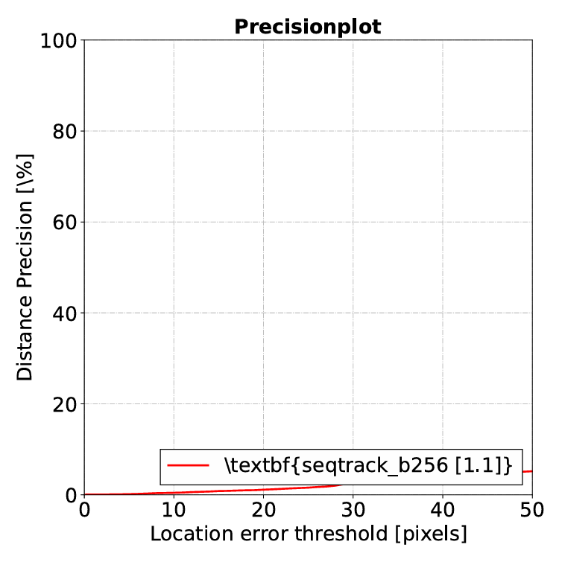

Results (Epoch 10):

Table 1: Inference rate results

Sequence | FPS
mouse-17 (ID=0) | 13.23
mouse-18 (ID=1) | 5.25
mouse-19 (ID=2) | 18.41
mouse-20 (ID=3) | 4.6
electricfan-17 (ID=4) | 11.61
electricfan-18 (ID=5) | 4.21
electricfan-19 (ID=6) | 15.98
electricfan-20 (ID=7) | 7.23

Table 2: Inference rate results

AUC | OP50 | OP75 | Precision | NormPrec
11.18 | 1.00 | 0.43 | 1.25 | 1.64

Graphs (Epoch 10):

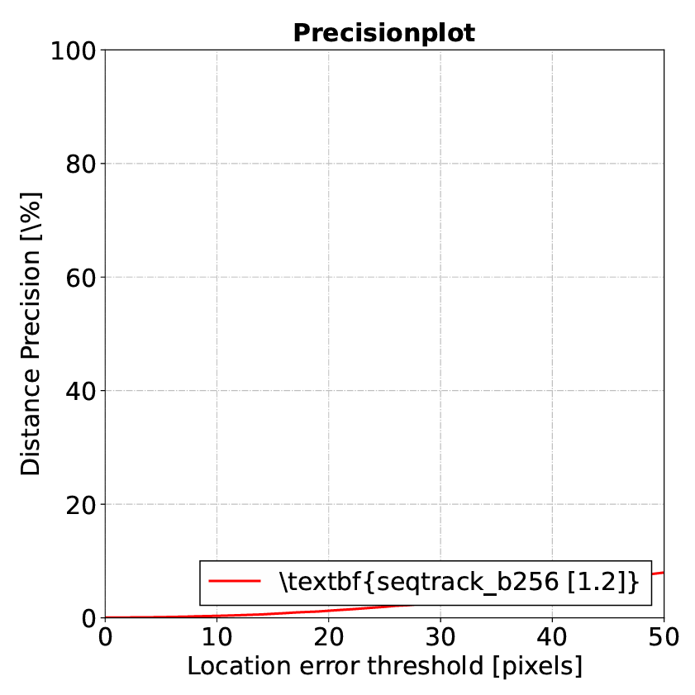

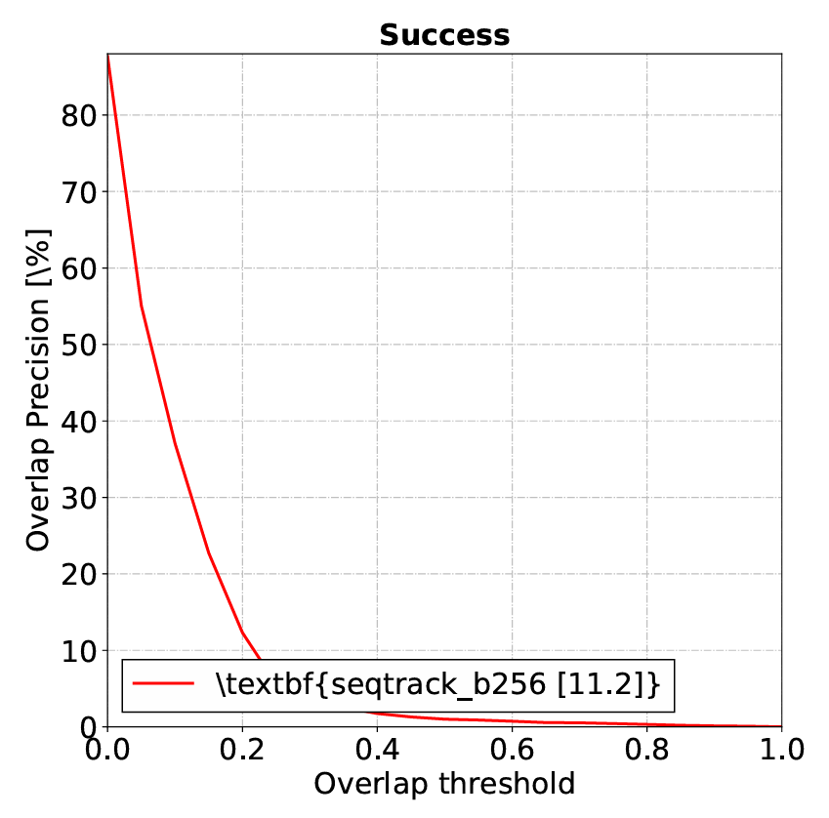

Reflection:

The SeqTrack testing and evaluation occur in two main steps: generating predictions in text files and then producing plots and accuracy metrics. The testing script first runs the trained model on each sequence to output frame-by-frame bounding box predictions. These results are then evaluated using the built-in code, which computes IoU, Precision, and AUC metrics and visualizes them in the Success, Precision, and Normalized Precision plots.

